JOB DESCRIPTION |  | 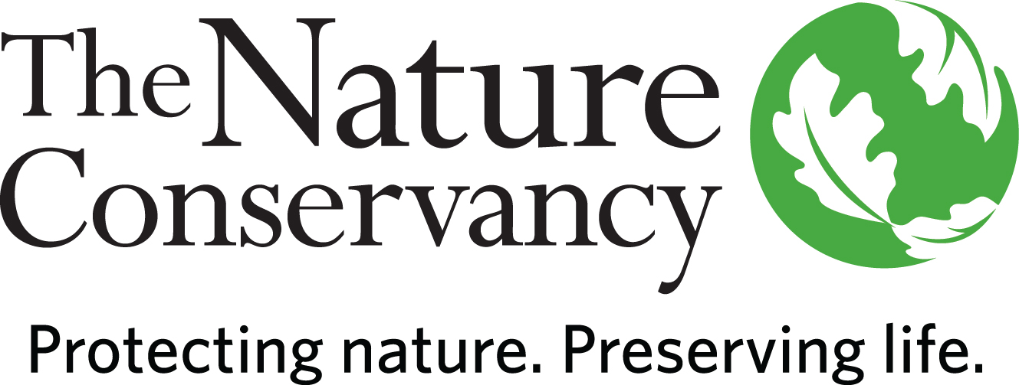
JOB TITLE | Freshwater Scientist - Applied Scientist II (ICR)
JOB FAMILY | Science
JOB NUMBER | 400006
SALARY GRADE | 7
STATUS | Salaried
DATE | April 2021
A LITTLE ABOUT US

Founded in 1951, the Nature Conservancy is a global conservation organization dedicated to conserving the lands and waters on which all life depends. Guided by science, we create innovative, on-the-ground solutions to our world's toughest challenges so that nature and people can thrive together. We are tackling climate change, conserving lands, waters and oceans at unprecedented scale, providing food and water sustainably and helping make cities more sustainable. One of our core values is our commitment to diversity. Therefore, we strive for a globally diverse and culturally competent workforce. Working in 72 countries, including all 50 United States, we use a collaborative approach that engages local communities, governments, the private sector, and other partners. To learn more, visit www.nature.org or follow @nature_press on Twitter.
YOUR POSITION WITH TNC

The Applied Scientist II (ICR) provides technical and scientific support and leadership for the Colorado River Program’s (CRP) conservation initiatives in Conservation by Design (CbD) and measures of conservation success (MOS).

ESSENTIAL FUNCTIONS

The CRP Freshwater Scientist will play a role in shaping water management strategies that help better meet the water needs of native species and habitats across the Colorado River Basin by conducting technical analysis and planning activities necessary to advance on-the-ground flow restoration and water infrastructure projects; providing water- and species-related technical input to the CRP team, TNC business unit partners, fundraising efforts, and multi-stakeholder coalitions; and guiding CRP’s conservation planning and measures work. They will classify conservation targets and assess data to prioritize watersheds/basins for conservation as well as provide technical input to assist the CRP in prioritizing conservation interventions. They conduct scientific surveys and research, records data, writes reports and develops proposals in order to support, inform, and prioritize CRP’s conservation actions. They provide technical input into CRP’s policy engagements on freshwater issues and brings agency and academic relationships to bear to advance conservation efforts in partnership with the CRP team and multi-stakeholder coalitions.

RESPONSIBILITIES & SCOPE

- Identify, evaluate, prioritize, and help design on-the-ground projects that will improve river health and function, demonstrate replicable solutions, and/or leverage change at the river basin and/or system scale.
- Work throughout the Colorado River Basin in collaboration with CRP’s business unit partners, NGO partners, and funders.
- Develop river restoration projects, agricultural irrigation infrastructure improvements, and flow restoration efforts – and analyze and measure their ecological impacts.
- Programmatic scope requires extensive cross-boundary work and relationships.
- Manage hydrology modeling projects to inform conservation strategies and actions.
- Build and participate in strategic partnerships and collaborations with partners such as academics, agencies, water districts and NGOs.
- Effectively communicate our conservation goals and the science supporting our work.
- Inform and review policies that support integrated water management to benefit nature.
- Work collaboratively with multi-disciplinary teams in a complex matrix organization environment.
- Provide fieldwork and logistical support for research, project development and monitoring.
- Design and implement experiments relative to program area.
- Responsible for partnering with philanthropy and grant administration staff to pursue public and private funds to meet program needs.
- Build cooperation with outside parties to accomplish program goals.
- Frequently makes independent decisions based on analysis, experience, and context.
- May lead staff, interns or volunteers on a project basis.
- May manage a grant, contract or request for proposal.
- Must be willing to travel within the Colorado River Basin, work in variable weather conditions, at remote locations, in hazardous terrain and under physically demanding circumstances.

MINIMUM QUALIFICATIONS

- Master's Degree in science related field and 5 years of experience or equivalent combination of education and experience.
- Demonstrated experience with freshwater ecosystem science.
- Experience leading and working with cross functional teams.
- Experience synthesizing, interpreting and communicating scientific information.
- Experience preparing reports of findings.
- Experience managing complex or multiple projects, including workloads, and budgets under deadlines.
- Experience in partnership development with non-profit partners, community groups and/or government agencies.
- Experience writing grants.
- Demonstrated ability to work as part of a team.
- Experience with hydrologic/discharge monitoring and modeling.
- Ability to communicate clearly via written, spoken, and graphical means in English.
- Demonstrated experience in grant writing and securing funding from foundations and government programs.
- Experience working and communicating with a wide range of people.

DESIRED QUALIFICATIONS

- A Master’s Degree in watershed science or related field (including, but not limited to, ecology, hydrology, hydraulic engineering, watershed management, fisheries biology).
- Working knowledge of western U.S. water rights and water allocation systems, with experience in Colorado River Basin preferred.
- Demonstrated experience with the freshwater ecosystems of the Colorado River Basin.
- Experience and familiarity with groundwater / surface water hydrology interactions.
- 10 years’ experience in watershed conservation practice, hydrology or equivalent combination of education and experience.
- Experience working with stakeholders. Particular preference given for experience working with the agricultural community.
- Experience with environmental water transactions.
- Understanding of agricultural irrigation technology and practices, and experience applying those practices.
- Knowledge of the structure, function, and operation of irrigation districts, water users associations, and ditch companies.
- Familiarity with Bureau of Reclamation, Reclamation policies, and Reclamation projects.
- Knowledge of current trends and practices in agricultural water management, water resources management, and natural resource conservation.
- Knowledge of Tribal interests and issues in the Colorado River Basin and experience working with Tribal Nations.
- Record of peer reviewed publications in scientific journals.
- Experience leading teams, including motivating, leading, setting objectives and managing performance towards deliverables.

- Experience in collaborating with scientists and other conservation practitioners to complete assessments and develop focused conservation priorities.
- Demonstrated experience developing and implementing on-the-ground conservation projects.
- Knowledge of current trends and practices in water management; water policy; agricultural practices; river, groundwater, and wetland restoration, particularly in western U.S. context; and watershed protection
- Demonstrated commitment to river and wetland conservation.
- Multi-language skills and multi-cultural or cross-cultural experience appreciated.
- Ability to meet deadlines.

ORGANIZATIONAL COMPETENCIES

Builds Relationships | Builds productive relationships by interacting with others in ways that enhance mutual trust and commitment.
Collaboration & Teamwork | Works collaboratively with stakeholders across levels, geographies, backgrounds, and cultures to improve decisions, strengthen commitment, and be more effective.
Communicates Authentically | Communicates proactively and in a timely manner to share information, persuade, and influence with the appropriate level of detail, tone, and opportunities for feedback.
Develops  Others | Takes ownership to help develop others’ skills, behaviors, and mindsets to help them maximize their workplace contributions.
Drives for  Results | Sets challenging goals and objectives based on a strong sense of purpose and high-performance standards and steadfastly pushes self and others for tangible results, while ensuring work-life balance.
Leverages Difference | Demonstrates commitment to harnessing the power of differences strategically; consistently sees, learns from, and takes strategic action related to difference; and demonstrates the self-awareness and behaviors to work across differences of identity and power respectfully and effectively with all stakeholder. Actively seeks to build and retain a diverse workforce and fosters an equitable inclusive workplace by drawing upon diverse perspectives.
Systems  Leadership | Thinks and acts from a broad perspective with a long-term view and an understanding of 1) the dynamic nature of large-scale challenges and 2) the need for integrating five key practices: skillfully engaging appropriate people; providing a clear process for change; taking a holistic view of situations; focusing on a small number of strategic actions, while learning from and adapting them over time; and being aware of how one’s own thinking or patterns of behavior may be limiting change.

This description is not designed to be a complete list of all duties and responsibilities required for this job.

